What Is ADHD?
Psychological disorder present at birth. However, the noticeable ADHD symptoms occur early in childhood. Before the age of 5, ADHD symptoms may be difficult to diagnose, because most young children are highly energetic, easily distractible, and impulsive.

A neurodevelopmental condition characterized by AGE INAPPROPRIATE BEHAVIOURS in areas of:
INNATENTION, HYPERACTIVITY AND IMULSIVITY
ADHD symptoms can be grouped into this classic triad of inattention, hyperactivity and impulsivity. When we are assessing symptoms we are looking for age inappropriate behaviours in these areas. Children & young people with ADHD often present as more immature than their peers.
True, many forms of inattention and impulsivity are normal in early childhood.
The key difference is that kids with ADHD display these behaviours much more frequently than their peers at the same developmental stage. The general rule of thumb is that kids with ADHD display these behaviours at three times the frequency of their peers.
As we discussed, every child with ADHD is different. But there are three different subtypes:
- Predominantly inattentive type (formerly called ADD)
- Predominantly hyperactive/impulsive type
- Combined type, exhibiting a combination of all three areas. This is the most common type of ADHD.
Current Understanding of ADHD
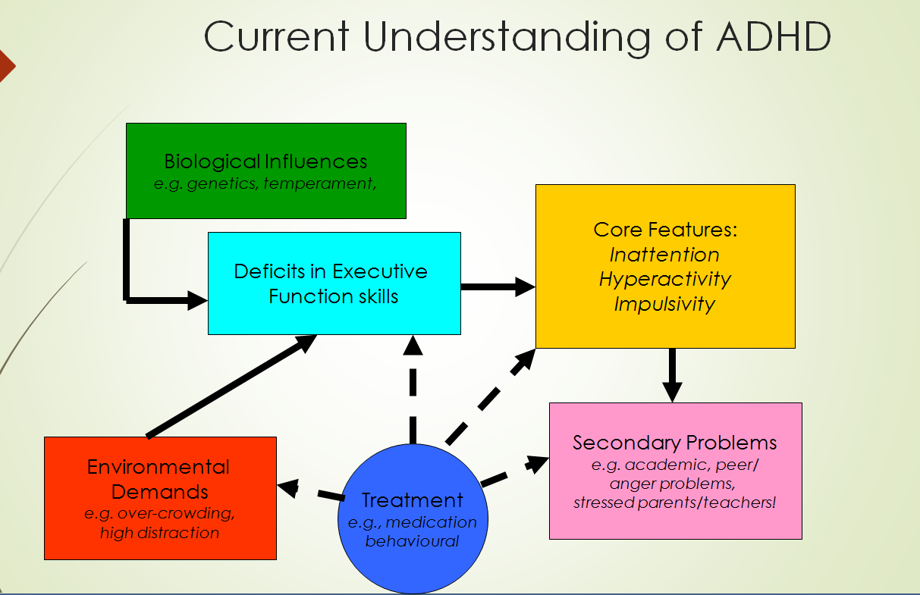

ADHD - Assessment

Taking a full history.

- A developmental assessment (to explore & eliminate other factors)

- Completion of parent & school questionnaires (eg. Conners Questionnaires) plus additional school report

Classroom observation (school age children)

DSM-IV ADHD Diagnostic Criteria

List of symptoms must be present for past 6 months

Must have six (or more) symptoms of inattention and/or hyperactivity–impulsivity

Some symptoms present before 7 years of age

Some impairment from symptoms must be present in two or more settings (e.g. school and home)

Significant impairment: social, academic or occupational

Exclude other mental disorders

Symptom Groups
Inattention: does not attend, fails to finish tasks, can’t organise, avoids sustained effort, loses things, ‘forgetful’, easily distracted
Hyperactivity: fidgets, leaves seat in class, runs/climbs excessively, cannot play/work quietly, always ‘on the go’, talks excessively
Impulsivity: blurts out answers, cannot await turn, interrupts others, intrudes on others
A diagnosis of ADHD by the DSM-IV requires the presence of six or more symptoms from at least one symptom group (inattention or hyperactivity–impulsivity).
Structural abnormalities
In individuals with ADHD, structural magnetic resonance imaging (MRI) analyses have identified reductions in the volume of various regions of the brain.
Functional abnormalities
Functional MRI studies have identified reduced levels of activity in various frontal regions of the brain of ADHD patients.
Physiological abnormalities
Abnormal patterns of brain activity may serve as a basis for differentiating ADHD from other psychiatric disorders and initiating more effective treatment.
Researchers have found that individuals with ADHD may be distinguished from those without ADHD using quantitative electroencephalography (EEG).
Chemical abnormalities
ADHD is associated with abnormalities in the neural systems that govern release of neurotransmitters such as dopamine (DA) and noradrenaline (NA).

ADHD and the Human Brain

Portions of brain’s frontal lobe are responsible for “Executive” functions:

These skills allow us to “organize our behavior over time and override immediate demands in favor of longer-term goals”

They also allow for the management of emotions and effective thought monitoring.

ADHD and the Brain

Research suggests that in children with ADHD, these “executive” areas of the brain are under-active

Increasing the activity level in these areas of the ADHD brain have been shown to decrease behavioral symptoms. This is the logic behind using Stimulant medications as a first line treatment for the disorder.

Co-occurring Disorders in Children
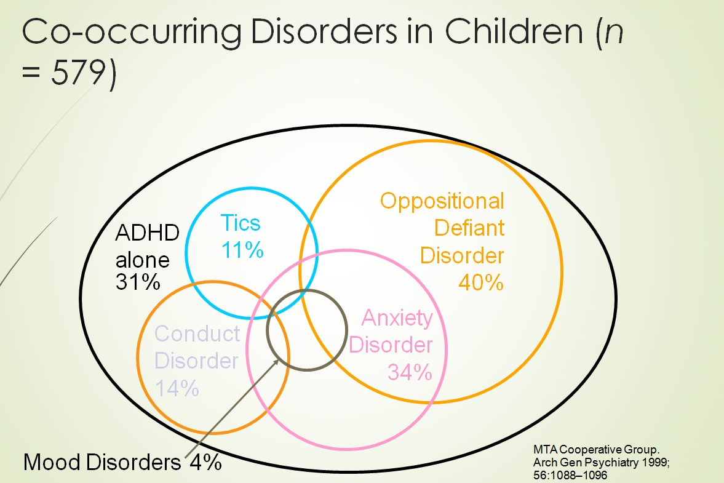

Gender Differences and ADHD

Boys are diagnosed with ADHD approx 4:1 compared with girls

The stereotype of someone with ADHD is a hyperactive little boy. The reality? ADHD also affects girls and even adult women.

Girls with ADHD tend to be more inattentive than hyperactive.

Parents and teachers often overlook ADHD in girls because their symptoms differ from the stereotype.

According to researchers, girls with untreated ADHD are at risk for low self-esteem, undesrachievement, depression, and anxiety and more likely to engage in risky behaviors like smoking and unprotected sex while in middle or high school.

Aetiology (causes) of the Disorder
Interplay of genetic & environmental factors

Genetic

ADHD runs in families & manifests with different degree of severity across generations

Environmental

Maternal smoking, alcohol consumption or heroin use

Very low birth weight

Fetal hypoxia

Brain injury

Exposure to toxins e.g. lead

Zinc deficiency
Parent-child relationship can contribute to or maintain ADHD behavior if parents give more commands and have more negative interactions. Family factors interact with genetic and neurobiological factors but do not cause them

What is the prognosis?

There is no cure for ADHD, BUT

Diagnosing & treating ADHD at a young age tends to improve prognosis

In most cases, ADHD can be effectively managed

Symptoms in most children will improve over time, although some symptoms may persist into adulthood

Interventions

Treatment of ADHD should be multimodal & may include

Medication

Educating parent/child about ADHD

Behavioural management

Education support services

ADHD is often under-diagnosed, over-diagnosed, misdiagnosed

